Software Automation Engineering Team

DESK PROCEDURE FOR SETTING UP POWERSHELL REMOTE USING HTTPS PORT 5986

Document Owner: Richard M. Williams
Editor: Richard M. Williams
Document name: Desk Procedure For Setting Up Powershell Remote Using HTTPS Port 5986.doc

Document Revision Number: v1.0
Date: 03-08-18
Document Status: Complete

Version Control
Version | Date | Author | Changes
1.0 | 03/08/18 | Richard M. Williams | Original Version
DESK PROCEDURE FOR SETTING UP POWERSHELL REMOTE USING HTTPS PORT 5986

- On the endpoint server where the cert will be created……goto START \ ADMINISTRATIVE TOOLS \ IIS MANAGER
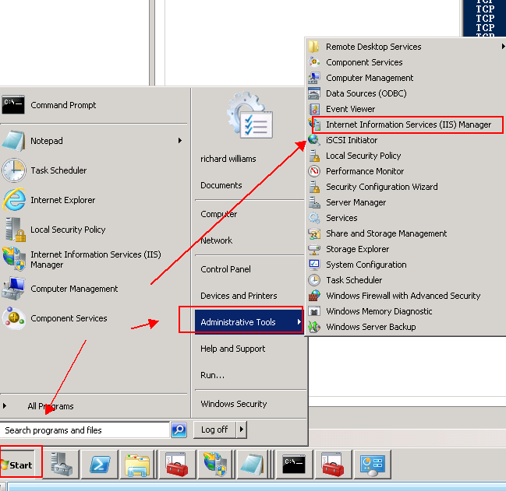

- Click on server name in left window pane
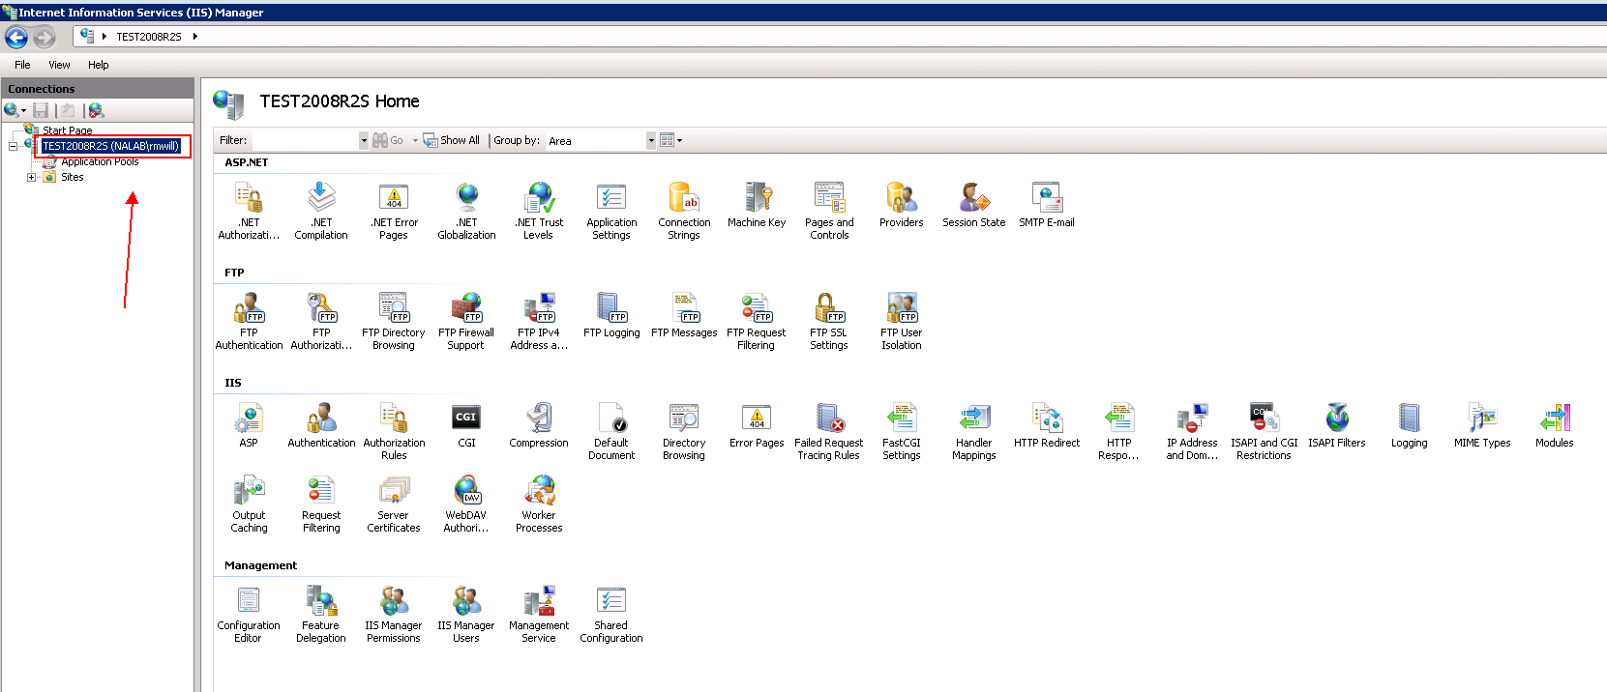

- Click on SERVER CERTFICICATES in main window pane under the IIS section
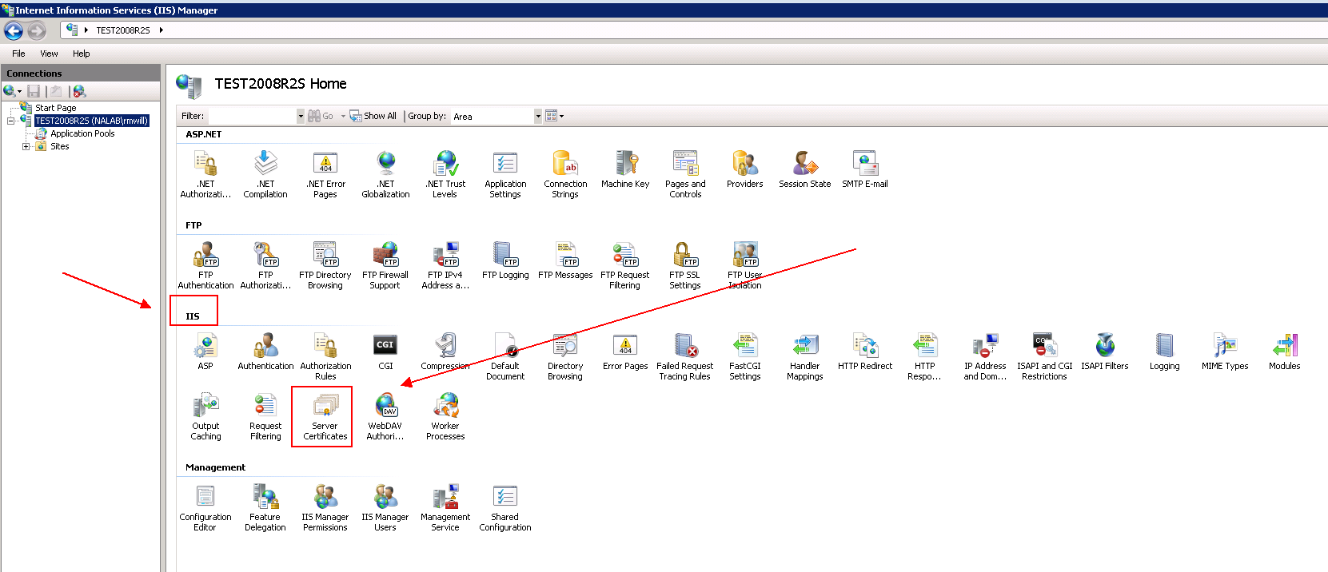

- Click on CREATE SELF SIGNED link on the right windows pane under ACTIONS
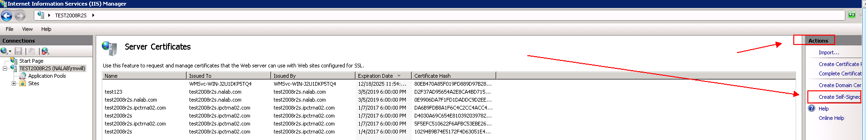

- Enter the FQDN name when prompted for with “specify a friendly name for the certificate” and click OK
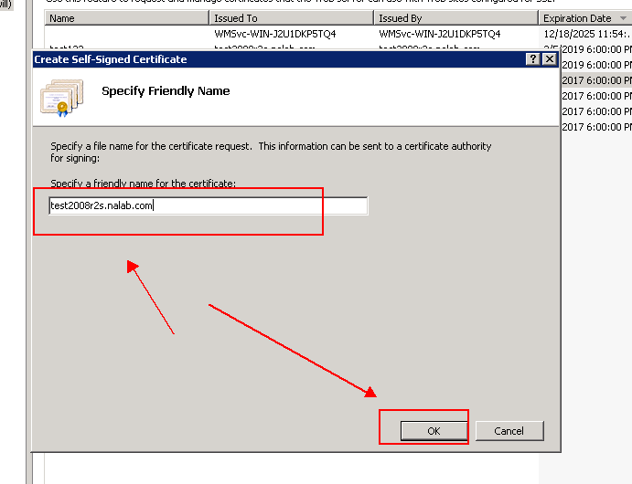

- Next, open the certificate you just created, and click on the DETAILS tab. Highlight the THUMBPRINT field and then Open a notepad document and copy\type the thumbprint value.
Antoher option would be to use the command below and find the certificate in question and copy \ paste the associated thumbprint
gci -Path Cert:\LocalMachine\My
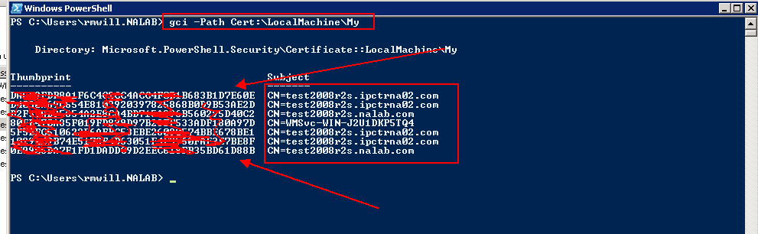

- create the https listener with the cert – USE DOS SHELL:
winrm create winrm/config/listener?Address=*+Transport=HTTPS @{Hostname="test2008r2s.nalab.com";CertificateThumbprint="0e9906da7f1fd1daddc9d2eec618fb35bd61d88b";Port="5986"}
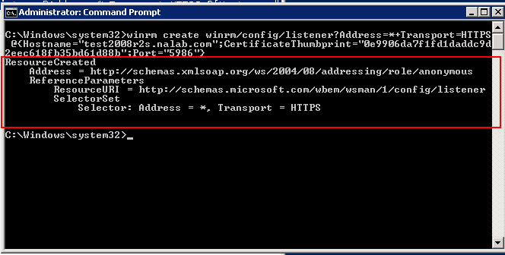

- check both HTTP and HTTPS ports and validate okay – USE DOS SHELL:
winrm enumerate winrm/config/listener
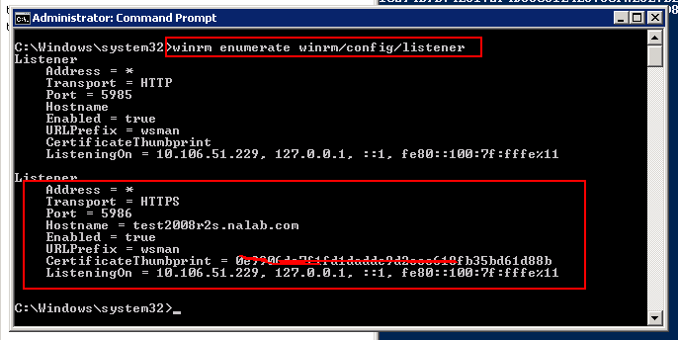

- Export the Cert (will require a password) by RIGHT-CLICKING on the Certificate name and then selecting EXPORT. Save the certificate locally and then copy it over to the Source machine which will initiate the powershell connections.
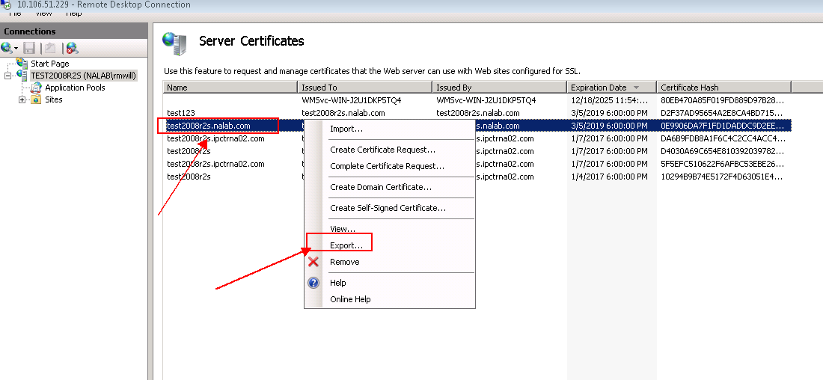

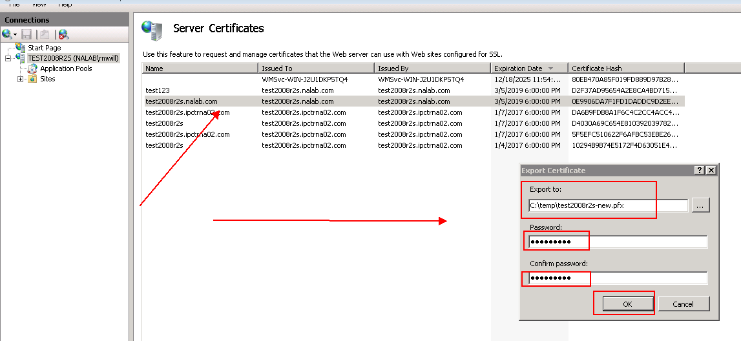

- NOW GO TO THE SOURCE MACHINE WHERE YOU WILL BE ISSUING THE POWERSHELL REMOTE COMMANDS (Steps # 9 & 11 – exporting & importing cert on source machine – may not be required for self signed certificates):
- Go the directory location where the certificate was copied to in step number 8 above. Import the certificate by double-clicking on it. You should be prompted for a password as well. The password was rendered in step #9 above.

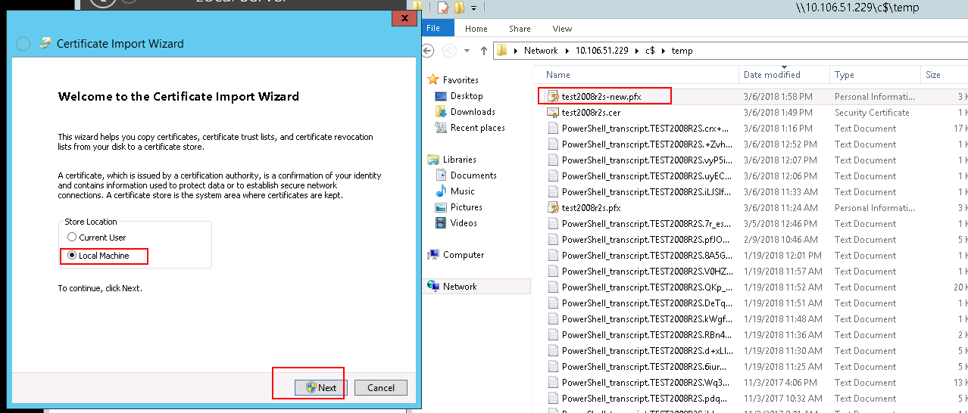
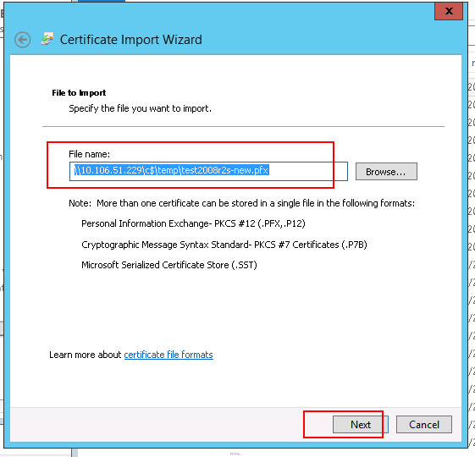
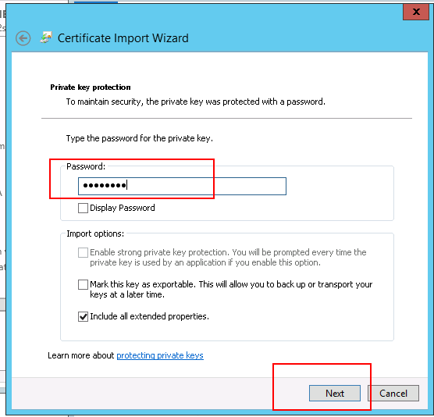
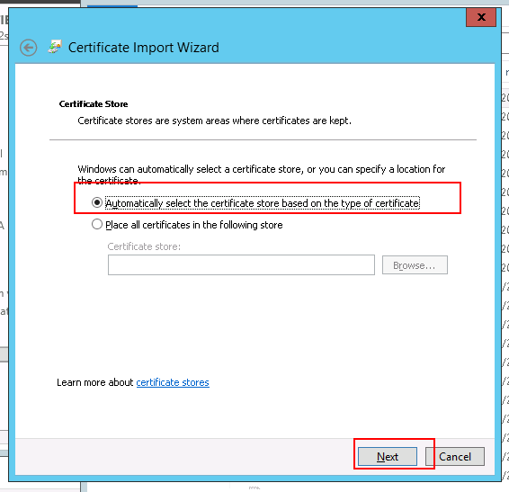
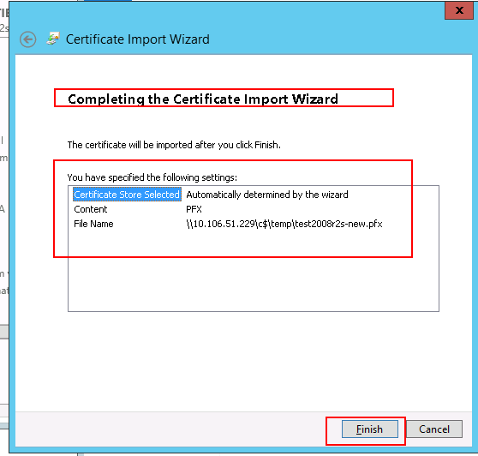
- Test connectivity to that endpoint server with the following powershell commands – Use Powershell session:
$mycreds="domain\userid"

$session_id=new-pssession -computername <fqdn of target server> -credential $mycreds -UseSSL -SessionOption $( New-PsSessionOption -SkipCACheck -SkipCNCheck)

Invoke-Command -Session $session_id -ScriptBlock {hostname}

Remove-PSSession $session_id

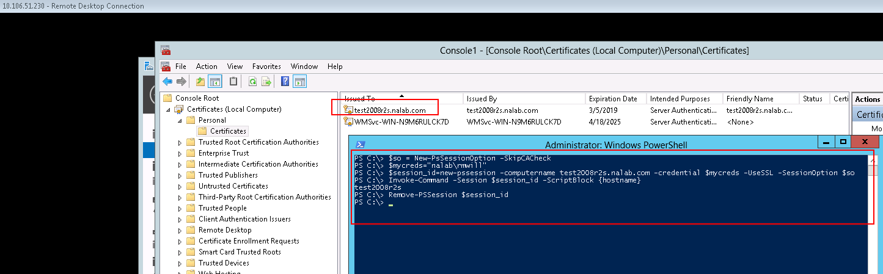

Additional commands:
To Delete HTTP Listener:
Winrm delete winrm/config/Listener?Address=*+Transport=HTTP
To Delete HTTPS Listener:
Winrm delete winrm/config/Listener?Address=*+Transport=HTTPS
Display Listener(s):
winrm enumerate winrm/config/listener
Display certificate(s) and their thumbprint(s):
gci -Path Cert:\LocalMachine\My
Create 5986 listener port with a certificate thumbprint:
winrm create winrm/config/listener?Address=*+Transport=HTTPS @{Hostname="<fqdn of server>";CertificateThumbprint="<certificate thumbprint>";Port="5986"}

REFERENCES:
https://blogs.technet.microsoft.com/uktechnet/2016/02/11/configuring-winrm-over-https-to-enable-powershell-remoting/
http://www.techdiction.com/2016/02/11/configuring-winrm-over-https-to-enable-powershell-remoting/
https://blog.jayway.com/2011/11/21/winrm-w-self-signed-certificate-in-4-steps/
https://support.symantec.com/en_US/article.TECH97514.html
https://support.symantec.com/en_US/article.TECH94458.htm
https://blogs.msdn.microsoft.com/wmi/2009/03/17/three-ways-to-configure-winrm-listeners/

